**Cloud computing introduction**

**Cloud Computing provides us a way through which you can access the applications just like utilities over the internet. It enables us to create, configure as well as customize the business applications online.**

In simple words, cloud computing demands running computer/network applications that are present at some other place on other people’s servers with the use of a simple user interface or application format.

**The term cloud computing can be understood as remotely using other people’s servers for running applications for your own organization**

Several years back the industry witnessed a new buzzword and technology called “virtualization”. With the advent of virtualization, the ideology of sharing computing resources across multiple operating systems to reduce capital costs, increase scalability and enable easy administration of the IT infrastructure became the backbone of several enterprises.

**Cloud delivery models**

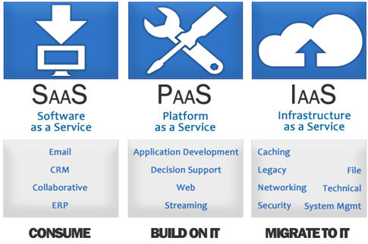

The cloud has mainly three types of delivery models or components that provide “as a Service” capabilities:

* **Infrastructure as a Service (IaaS)**: This is the most fundamental layer which forms the building block of the cloud. It mainly comprises of physical resources such as Storage, Network devices, compute servers, etc. All these computing resources are available on demand, where a user pays as per his usage.
* **Platform as a Service (PaaS)**: The central layer in the cloud Is the platform**.( It provides the runtime environment for applications,  tools for development and deployment, etc.)** Here there is no control over the underlying infrastructure but you can access the deployed applications. Hence this provides the entire runtime environment on demand which could be a development or test environment. Hence in this model, most commonly you would have a VM that contains the complete environment like OS, required middleware, etc. available when you need it.
* **Software as a Service (SaaS)**: The topmost layer here is the application layer, which is generally visible to any user. Here, applications / products are available to the user on demand via the internet. **(This model allows end-users to use software applications as a service.)**Hence instead of having to acquire licenses for a particular user, this proves to be the most cost effective way of making sure that the license is always in use. Examples of this are Gmail, Google docs, Photoshop, etc.

Two newer module which are added in order to enhance cloud computing technique are

* Identity-as–a-Service (IDaaS).
* Network-as-a-Service

**Types of cloud**

**There are 3 types of cloud formations: public, private and hybrid clouds:**

* **Public clouds** are where services are available to everyone, where the resources are allocated and provisioned dynamically as per request.
* **Private clouds** are generally managed within firewall rules of a particular organization and are available only to the users within the company.
* **Hybrid clouds** are a mixture of private and public clouds. Organizations can decide what services they want to expose to everyone and what services they want to expose to only the users within the organization.